From: http://davidstockmanscontracorner.com/janet-yellen-powell-the-casinos-new-money-bitch-part-1/
See also: 20181126 No MAGA For The Donald, The Problem Is Bad Money, Not Bad Trade Deals, Part 1 ++++.doc

Janet Yellen Powell---The Casino's New Money Bitch (Part 1)
By David Stockman. Posted On Thursday, January 31st, 2019
At the time of his appointment, we took to referring to Chairman Powell as Janet Yellen in trousers and tie. We certainly got that right.
After all, if the US economy is a "solid" as the Eccles Building claimed in yesterday's statement--- the lowest unemployment rate in 40 years and healthy GDP growth---why in the world does the Fed need to pause its normalization cycle with the inflation-adjusted funds rate at just 0.1% and its balance sheet still hideously bloated at $4.0 trillion?
Yet that's exactly what these cowardly geniuses did. They removed any reference to future rate hikes from their post meeting statement, and then added a note of "additional information" that amounted to saying they didn't mean their balance sheet shrinkage program is on autopilot after all.
So doing, they demonstrated once again that they are clueless about the actual impact of their policies. That is to say, their radical interest rate and balance sheet policies have not stimulated the main street economy in the slightest because households are at Peak Debt and the C-suites of corporate America have been turned into stock trading rooms and financial engineering joints.
As we have demonstrated elsewhere, the tepid and halting recovery which has materialized since June 2009 did not happen because of Washington policy, but despite it. That is, business cycle recoveries always stem from the natural growth resilience of America's capitalist economy and the propensity of businesses, workers, entrepreneurs, investors and speculators to produce more and to strive to better their lot.
That the current s0-called recovery (blue line) is so anemic compared to every cycle since 1950, therefore, is owing to the strongest ever headwinds from Washington policy and to the cumulative debt burdens on capitalist growth that has been accreting for the last five decades.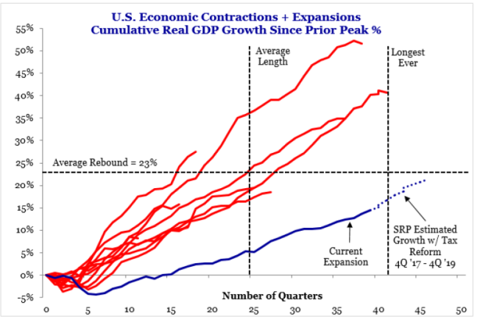
What this means, of course, is that the impact of the Fed's massive post-crisis interest rate repression and egregious bond-buying (QE) campaigns never left the canyons of Wall Street.
These frontal attacks on the requisites of
- sound money and
- honest price discovery in the money and capital markets
merely reflated financial asset prices into the Everything Bubble; and, now, rather than face the music of finally permitting it to deflate, our spineless monetary central planners have triggered another round of blind speculation in the casino that will only make the eventual reckoning all the more traumatic.
So the truth of the matter can be baldly stated. The nation's central bank has been turned into the casino's compliant bitch because that's the inherent end game of Keynesian central banking.
By completely destroying honest financial signals and market based financial discipline, the Fed's administered, pegged, propped and falsified asset pricing regime has guaranteed that the current Everything Bubble will collapse of its own weight in a spectacular flame-out----and one which will put all previous financial busts to shame.
Stated differently, after three decades of wrong-headed money-pumping and financial asset price falsification, the Fed's own policies have destroyed all remaining links between central bank policy actions and the main street economy.
Accordingly, the Fed's traditional playbook is non-operative. Low interest rates do not cause households to borrow more and they actually induce corporate America to invest less.
That is, to strip-mine their own balance sheets and cash flows in pursuit of Wall Street pleasing financial engineering (stock buybacks, M&A deals, special dividends etc) rather than boost investments in productive plant, equipment, technology and intellectual property.
Yet now that its actions and words have been reduced to short-run appeasement of the trading gods, the days of Keynesian central banking are numbered. The Fed's "credibility" is 90% shot and the balance will be obliterated by unfolding events in short order.
To be sure, Powell and Co. claim their capitulation to the casino was owing to the "in-coming data", but that's clearly a spurious rationalization. The only thing different about the main street economy between December 19, when Powell was chirping a hawkish tune, and yesterday is that following his last post-meeting presser the DOW plunged by 1800 points in four sessions, thereby bringing the wrath of both the Donald and Wall Street down on the Eccles Building with malice aforethought.
So while the Fed completes its final cowardly self-destruction tending to the daily stock price averages, it is worthwhile to remind once again why the leading Fed head ended up cowering helplessly with his legs akimbo in the Wall Street casino.
The technical answer is that the traditional channels of monetary policy transmission have been destroyed by the monumental debt binge the Fed stimulated after the 1971[Camp David]. We refer to the latter as America's rolling LBO and the proof is staggering.
Back in 1970 when the US dollar was still anchored to a fixed weight of gold and to the Bretton Woods system of fixed exchange rates and worldwide financial discipline, the ratio of total public and private debt to national income was just under 1.5X; and, as it happened, that ratio had been virtually constant for the previous one-hundred years.
But especially after Alan Greenspan launched the modern era of Keynesian central banking and massive money pumping in 1987, household, business, government and financial sector debt in the US has gone parabolic, rising from barely $10 trillion in 1987 to $53 trillion on the eve of the financial crisis in early 2008.
Since then, and notwithstanding all the ballyhoo about post-crisis deleveraging, credit market debt outstanding has continued to climb to just under $70 trillion (blue area), even as national income (GDP) has just reached the $20 trillionmark (orange area).
In this world of big numbers, however, there is a very simple way to cut to the chase. It cannot be denied that during the century between 187o and 1970, when the US leverage ratio [Debt/Income] adhered tightly to the golden mean of leverage at around 1.5X income, the American economy grew and prospered like no other economy in recorded history until then.
By contrast, 48 years after the asphyxiation of sound money at Camp David we have a struggling economy carrying a debt burden equal to nearly 3.5X national income. Investment bankers would call that "two extra turns" of debt relative to the historic 1.5X leverage ratio.
In round terms, those two extra turns amount to $40 trillion!
That's the number which measures the incremental debt the American economy has taken on during the course of this multi-decade rolling LBO; and it's the fundamental reason that easy money debt doesn't stimulate the main street economy any longer.
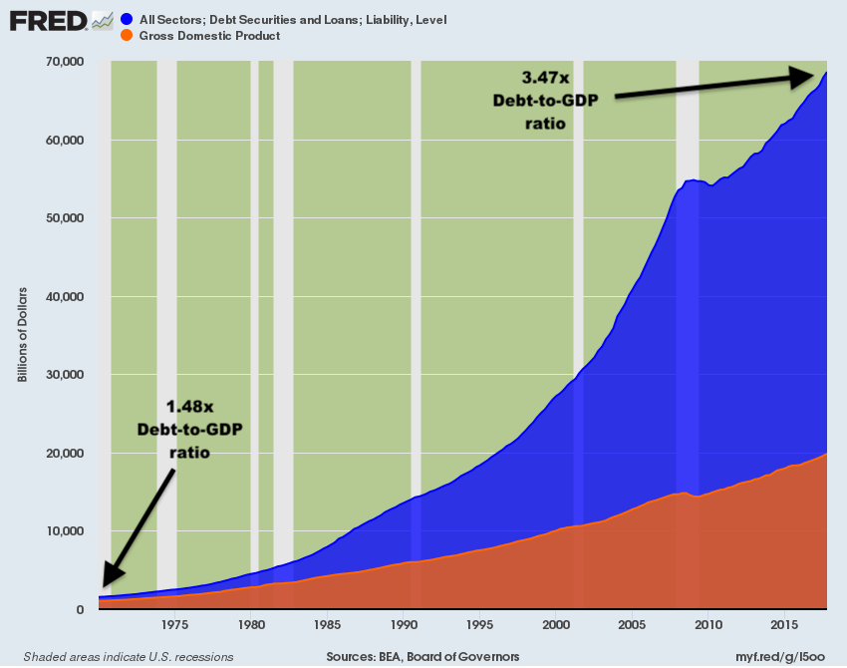
Indeed, it does not take a PhD in economics to see that the overwhelming share of US households are stranded at Peak Debt, and cannot and will not borrow more in response to the Fed's absurdly low interest rates. To grasp that truth you only need ponder the message of the chart below, which tracks the relationship of household debt to wage and salary income since Tricky Dick deep-sixed the Fed's Bretton Woods shackles back in August 1971.
In June 1971, household debt stood at $496 billion while wage and salary income clocked in at a $585 billion annual rate. So, as it had been for decades of American prosperity, total household borrowings---credit cards, installment debt, mortgages and all other loans----amounted to just 84% of wage and salary income. That ratio stood for stable prosperity and rising middle class living standards.
The implicit financial discipline in the system was that there were no financial guarantees: Jobs and income could be lost to business cycle downturns, the market based carry cost of consumer interest was heavy and the risk of an unexpected rise in rates was palpable. So households leveraged themselves prudently.
No longer---not in the age of bailouts and central bank financial dominance. Accordingly, the household leverage ratio has soared---especially after Greenspan formally embraced Bubble Finance in October 1987.
Just prior to his arrival at the Fed, in fact, household debt stood at $2.8 trillion compared to wage and salary income of $2.4 trillion. So by that point the household leverage ratio had already crept up to 117% debt-to-income.
And then it was off to the races. Between 1987 and the pre-crisis peak in the fall of 2007, household debt soared at a 8.5% per annum rate to $14.4 trillion. By contrast, wage and salary income grew by only 5.2% annually to $6.5 trillion.
As a result, the household leverage ratio literally erupted to an off-the-charts 221%. During that 20 year period, the household debt level nearly went parabolic as evident in red line in the chart below. And while it was happening, it acted as an accelerator on PCE (personal consumption expenditure) growth, which accounts for more than 70% of total GDP.
Alas, Peak Debt has set in since then. While the absolute level of household debt increased by about $1.1 trillion to $15.5 trillion during the last 11 years, the ratio to wage and salary income has fallen sharply-----reaching 175% during Q3 2108.
What that means is that the Fed's household spending accelerator has gone AWOL. Now rather than supercharging household spending from earned wage and salary income with incremental spending funded by higher leverage and borrowings against current income----just the opposite has happened.
To wit, rather than stealing from the future, households are actually paying back prior excesses. So the household sector has been forced to essentially live within its means, spending what it can earn, not what it can borrow on top.
As a result, the Fed's insane nine-year spree of virtually zero money market interest rates had no impact at all on the 70% of GDP attributable to PCE.
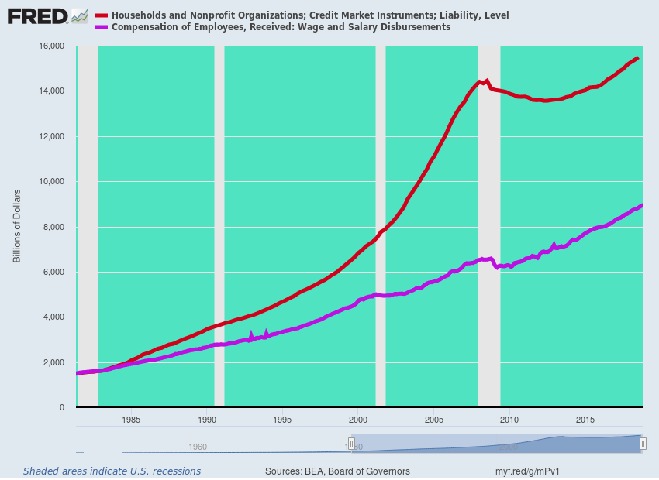
What ZIRP did impact, of course, was the carry cost of Wall Street speculation. As it happened, the Fed foolishly pegged the money market rate to the zero bound for seven straight years (from December 2008 to December 2015). In fact, with only a handful of monthly exceptions, the Federal funds rate (purple bars) has been well below the annual inflation rate (brown bars) for 107 months running.
That means money market rates have been negative in real terms for nearly a decade, yet negative carry costs are the mother's milk of speculation on Wall Street, and this time the Fed has fueled a full decade of exactly that. It's why the casino is chock-a-block with financial explosive devices (FEDs) from stem to stern.
Nine Years of Negative Real Interest Rates
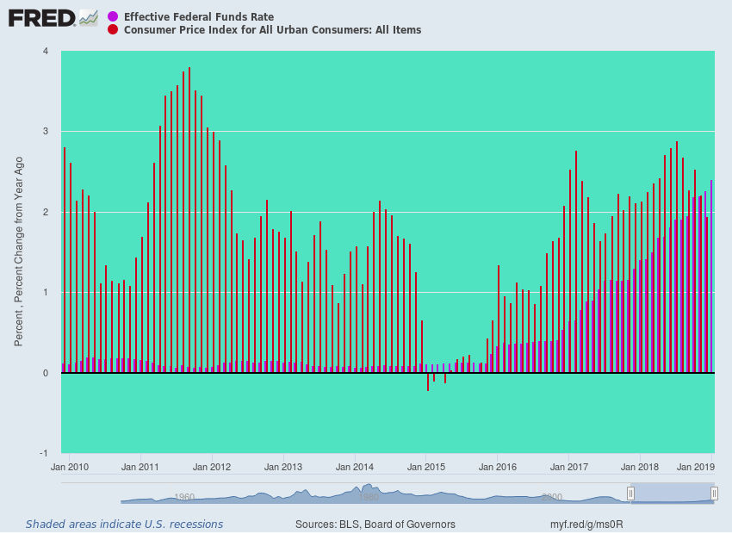
So as these reckless and interconnected bets continue to unwind---sometimes violently so---the Fed and other central banks will be impotent to arrest the carnage.
In part, that's because the magnitude of bottled-up speculation in the financial system after seven years on the zero-bound and nearly nine years of negative real interest rates simply dwarfs the build-ups which previously occurred during the dotcom/tech bubble and the Greenspan housing and credit bubble. During those bubble expansions, the Fed had pegged the funds rate at a far higher bottom and then for only a few quarters, not nine years, as is evident in the chart above.
In part 2, we will address why the monetary policy transmission channel is not only broken on the business side of the US economy, as well, but why this has actually turned the C-suites of corporate America into handmaids of Wall Street speculation.
In the meanwhile, Michael Lebowitz summarized it well after yesterday after Powell's presser:
“In our opinion, the Fed’s new warm and cuddly tone is all about supporting the stock market. The market fell nearly 20% from record highs in the fourth quarter and fear set in. There is no doubt President Trump’s tweets along with strong advisement from the shareholders of the Fed, the large banks, certainly played an influential role in persuading Powell to pivot.
Speaking on CNBC shortly after the Powell press conference, James Grant stated the current situation well.
“Jerome Powell is a prisoner of the institutions and the history that he has inherited. Among this inheritance is a $4 trillion balance sheet under which the Fed has $39 billion of capital representing 100-to-1 leverage. That’s a symptom of the overstretched state of our debts and the dollar as an institution.”
They got that right. What Powell's abject retreat during the past month really shows is that a complete end to Keynesian central banking is essential if capitalist prosperity itself is to survive.

Tricky Dick's disastrous lurch to 100% state controlled money at Camp David in August 1971

